Aamir Patel

IS 215

DFD Workshop

Sally’s FloraFills

Context DFD

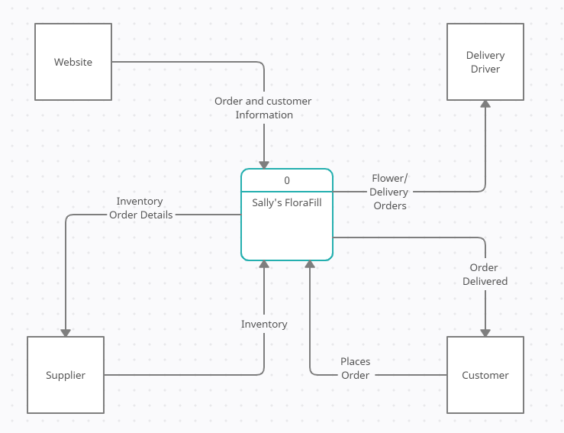

Level 0 Process DFD

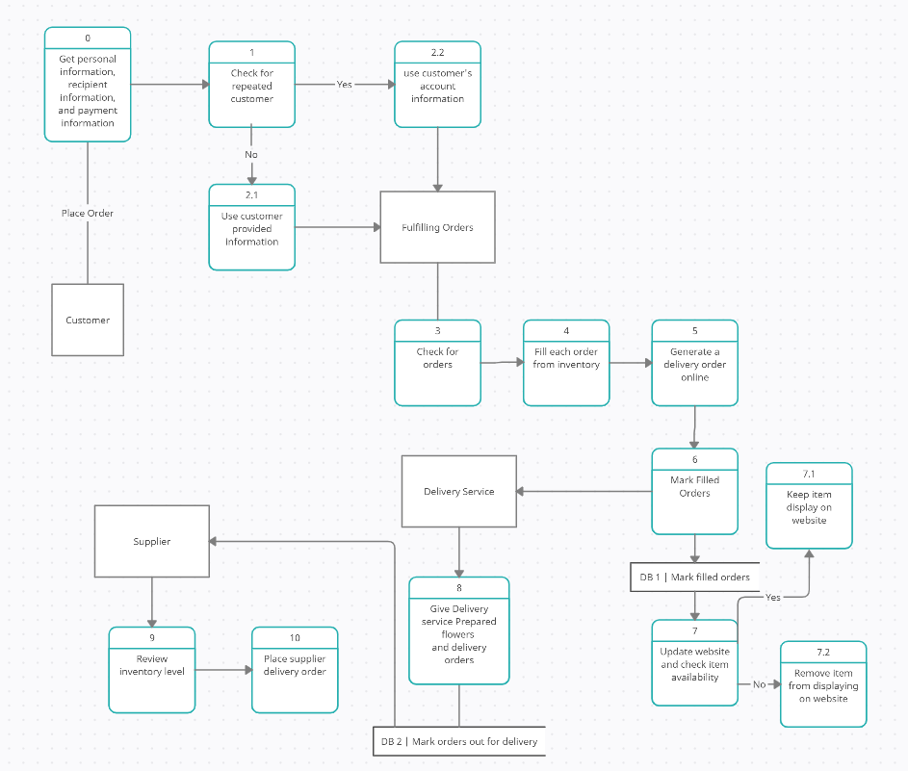

Functional Decomposition Diagram

